

REQUIREMENT PLAN

**Version1.0**

**Trịnh Như Phương**

**1/11/2019**

**VERSION HISTORY**

|  |  |  |  |  |  |
| --- | --- | --- | --- | --- | --- |
| **Version #** | **Implemented**  **By** | **Revision**  **Date** | **Approved**  **By** | **Approval**  **Date** | **Reason** |
| 1.0 | Trịnh Như Phương | 1/11/2019 | Đạt Huỳnh | 5/11/2019 |  |
|  |  |  |  |  |  |

Table of Contents

1. Purpose 6

2. Project overview 6

3. Process 6

4. Roles and responsibilities 6

5. Document 7

6. Scope 7

7. Reference 7

**List of Figure**

*Figure 1. Requirement Process* 6

**List of Table**

*Table 1. Roles and Responsibilities* 7

*Table 2. Document* 7

1. **Purpose**

The purpose of requirement management is to establish a common understanding of the technical and non-technical requirements that will be addressed by the project or organization between the customer and project or organization, within the project or organization, and throughout the lifecycle. The goals of requirements management are to ensure that requirements are controlled to establish a baseline for development, acquisition, or management; and to ensure plans, work products, and activities are consistent with the requirements.

1. **Project overview**

* Real Estate Management App is a software to support internal management of companies including view information, statistics, reports, happy birthday, business management, job management, customer management, decentralization

.

1. **Process**

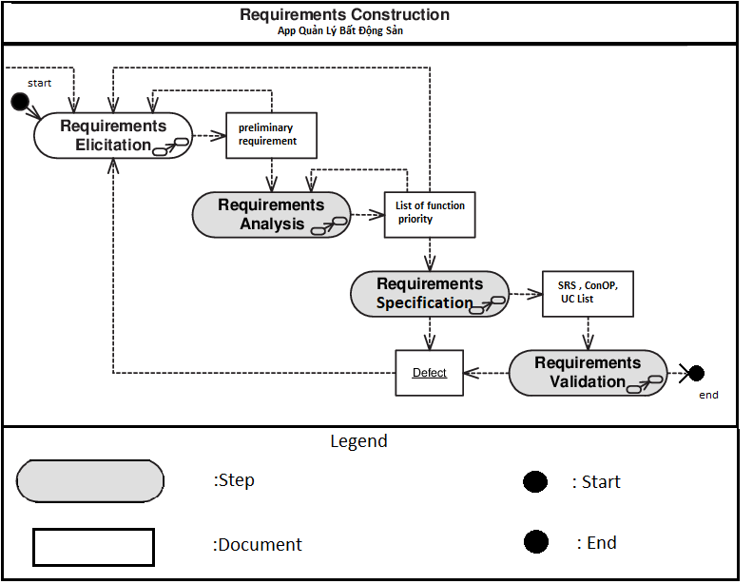

*Figure 1. Requirement Process*

1. **Roles and responsibilities**

|  |  |  |
| --- | --- | --- |
| **Role** | **Name** | **Responsibility** |
| Requirement Leader | Trịnh Như Phương | * Manage schedule * Assign tasks * Review documents * Elicit, analyze document requirements |
| Requirement Engineer | All member | * Elicit requirements * Make prototypes * Analyze requirements * Research information for developing requirements * Document specifications |
| Stakeholder | * Customer: Nguyễn Minh Châu * User: leader company, manager, staff | * Provided requirement that they need system interactive. * Validate User Requirement and Software Requirement Specification to ensure enough requirement that they need. |

*Table 1. Roles and Responsibilities*

1. **Document**

|  |  |
| --- | --- |
| **Document** | **Date** |
| Requirement Plan document |  |
| Traceability Matrix |  |
| ConOp |  |
| UCD |  |

*Table 2. Document*

1. **Scope**

The scope of the plan includes:

* What must be done?
* How it shall be done?
* Who will perform various activites?
* When they must be performed?
* What level of requirement quality must be achieved?

1. **Reference**